**DAILY ONLINE ACTIVITIES SUMMARY**

|  |  |  |  |  |  |  |  |  |
| --- | --- | --- | --- | --- | --- | --- | --- | --- |
| **Date:** | **09-07-2020** | | | | | **Name:** | **Raksha S** | |
| **Sem & Sec** | **6th B** | | | | | **USN:** | **4AL17CS073** | |
| **Online Test Summary** | | | | | | | | |
| **Subject** | | **-** | | | | | | |
| **Max. Marks** | | **-** | | **Score** | | | **-** | |
| **Certification Course Summary** | | | | | | | | |
| **Course** | **-** | | | | | | | |
| **Certificate Provider** | | | **-** | | **Duration** | | | **-** |
| **Coding Challenges** | | | | | | | | |
| **Problem Statement:**  1. Write a C Program to rotate an array by K positions. Circular array rotation means rotating the elements in the array where one rotation operation moves the last element of the array to the first position and shifts all remaining elements to the right. | | | | | | | | |
| **Status:** YES, Completed all Programs | | | | | | | | |
| **Uploaded the report in Github** | | | | | **YES** | | | |
| **If yes Repository name** | | | | | <https://github.com/raksha05/Daily-Status>/Raksha-4AL17CS073/Raksha | | | |
| **Uploaded the report in slack** | | | | | **YES** | | | |

**SSCD**

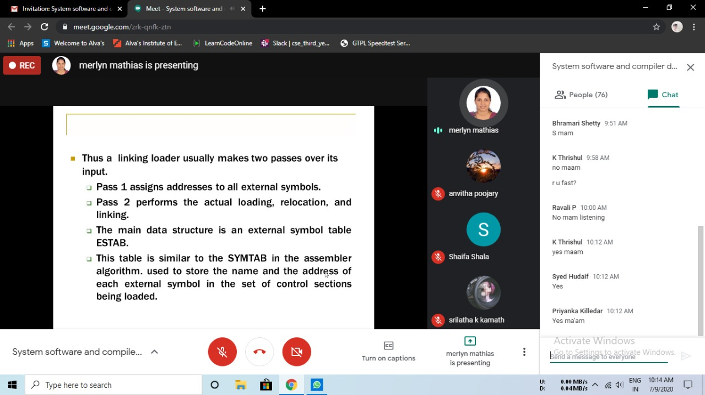

Coding Challenges Details:

Program1:

